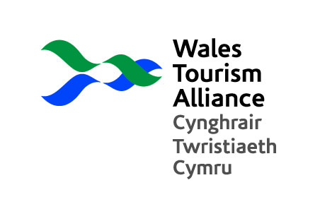

WTA Statement: Over-tourism and Tourism Tax - the cure for all Wales tourism’s ills?

1. Context

With the increasing use of the words ‘over-tourism’ to potentially justify a Tourism Tax in Wales, the WTA is proposing that a new body of research is commissioned to establish a clear route through the debate and ensure that the discussion surrounding Government consultation is not dominated by public sector interests alone.

The need for a factual base of information drawn from the tourism community is important and we recognise the need for local communities and local assets to be protected. However, the tourism industry also needs to be properly consulted and this has become extremely urgent given the imminent consultation that is to arise from the announcement of the Welsh Government’s three-pronged approach.

2. Background

Over-tourism, or perhaps a better phrase would be unbalanced tourism, undoubtably has an impact on local communities, particularly in “honeypot” destinations with pressures placed on built and natural resources. Congestion at peak times of the year such as Bank Holidays has led to understandable local resentment, which in extreme cases has led to alienation between visitors and host communities. Whilst being an issue in some parts of Wales, it is an increasing global phenomenon, fuelled by greater economic prosperity and improved transport links. Post Covid-19 a shared characteristic amongst all nations has seen the growth of staycation markets due to the curtailment of international travel. Pressures have been felt in mainstream destinations within many countries as lockdown restrictions ease and people have sought to escape from their local environments.

Concerns have been raised in Wales over the seasonal pressures created by tourism on local authority resources and impacts placed upon cultural and natural assets. In reality, this is confined to a number of specific locations and is by no means endemic in every community across Wales.

The WTA is concerned that there is a danger that irreversible decisions could soon be undertaken across Wales that will have unforeseen consequences in relation to its impact on the tourism economy and the viability of tourism itself. Before we enter into irreversible development of new legislative instruments it is imperative that the arguments for and against new regulation and taxation are thoroughly exercised.

We also recognise that post-Brexit; post Pandemic; with electrification and a new awareness amongst consumers as to their impact on local communities that this is a time for change and that we are not simply looking to block new proposals. At the outset, all we are asking for is a clear unbiased debate and the resources required to gain the information we need to enter into that debate.
The WTA therefore propose that whilst the Welsh Government build their own picture of the cultural, social and economic impact of tourism in identified areas of Wales, that the tourism industry is enabled to survey and interview representatives from cross sections of the tourism industry, to ascertain opinion on the key issues, relevance and likely approval of a number and/or combination of mitigation measures. These could relate to regulatory and non-regulatory instruments in relation to individual businesses and destinations. The WTA is prepared to exercise Welsh Government proposals if we are party to discussions early enough in the process.

3. Research Task

The aim will be to explore:

  - Businesses perception of the current taxation load: inc. direct taxation (NDBR, Capital Gains) and indirect (VAT) in relation to other overheads, inc labour; material and service charges.
  - An exploration as to the reception of businesses to various models of tourism tax and its application.
  - The establishment of when a tourism tax would be acceptable i.e. reducing the tax burden elsewhere or if the business could see a direct benefit back to the business.

WTA - November 2021

